Nepal College of Information Technology
Assessment
Spring 2010
Program : BE ELX/CE Time : 3 hrs
Semester : Spring (II) FM : 100
Subject : Applied Mechanics PM : 50
- Candidates are requested to give their answer as far as practicable in their own words.
- The figure in the margin indicates the full marks
- Attempt ALL question
1. a. A horizontal circular plate weighing 62 N is suspended as shown form three wires that are attached to support D and that form 30° angles with the vertical. Determine the tension in each wire. [7]
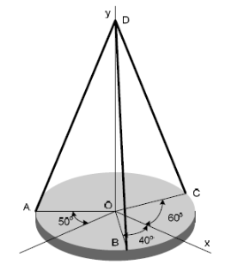.

b. Two spheres A and B are placed in a container as shown in figure. Determine the reaction from the walls of the container. [8]
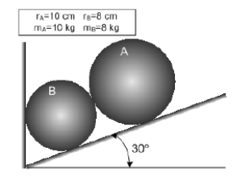
2. a. Find the friction force for the block shown and state whether the block is in equilibrium or in motion. Also determine the additional force P that must be added to 140 N forces to just move the block to left. [8]
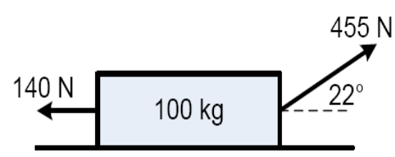

b Determine centroid of given area. [7]
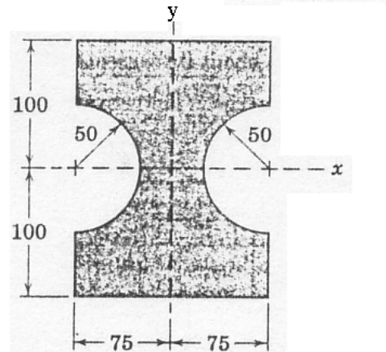

3. a The acceleration of the particle is directly proportional to time t. At t=0, the velocity of the Particle is 400mm/s. Knowing that v= 360mm/s and x= 500mm when t= 1s, determine the Velocity, the position and the total distance traveled when t= 7s. [7]

b A homeowner uses a snow-blower to clear his driveway. Knowing that the snow is discharged at an average angle of 40° with the horizontal, determine the initial velocity vo of the snow. [8]

. 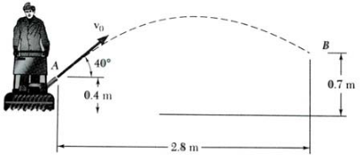
4. The two blocks shown are originally at rest. Neglecting the masses of pulleys and the effect of friction in the pulleys and assuming that the coefficients of friction between block A and the horizontal surface are μs =0.25 and μk =0.2 determine
a) The acceleration of each block
b) Tension in the cable [15]

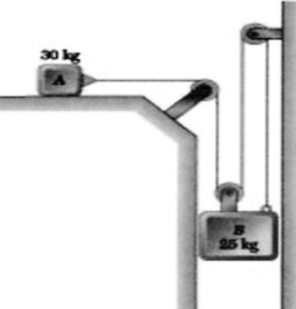

5. A small block starts from rest at point A and slides down the inclined plane as shown. What distance along the horizontal plane will it travel before coming to rest? The coefficient of kinetic of friction between the block and either plane is 0.3. Assume that the initial velocity with which it starts to move along BC is of the same magnitude as that gained in sliding from A to B. [15]

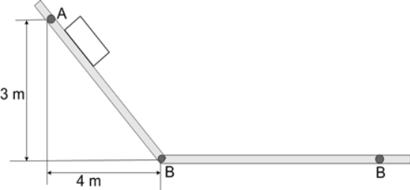

6. A ballistic pendulum consists of a sand box weighing 5 kg that is suspended from a cord 3 m long. A 50 g shell is fired horizontally in the box and remains embedded in it. Because of impact, the sand box swings through a maximum angle 30°, as shown. Determine the velocity with which the shell strikes the box and loss in energy of the system. [15]
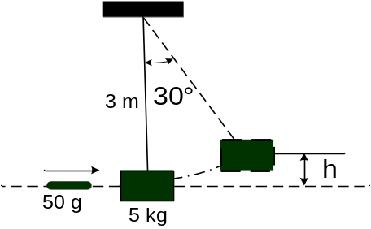

7. Write short notes on(any two) [2 X 5=10]
a) Angle of friction
b) Principle of work and energy
c) Force

